Parth Babbar

HOME EQUITY LINES OF CREDIT

**Introduction:**

A Home Equity Line of Credit (HELOC) is a revolving loan that allows homeowners to borrow against the equity in their houses, much like a credit card. This line of credit allows homeowners to draw cash as needed, up to a pre-approved maximum, for a variety of objectives such as home upgrades, education expenditures, or debt consolidation.

**Features & How it Works:**

1. **Secured Loan:** HELOCs are secured by the borrower's house, which lowers the lender's risk.
2. **Revolving Credit:** HELOCs provide a revolving line of credit, allowing borrowers to draw, repay, and redraw cash in a manner similar to a credit card.
3. **Variable Interest Rates:** Most HELOCs have variable interest rates based on the prime rate.
4. **Draw term: T**he first term in which borrowers can access money, which typically lasts 5 to 10 years.
5. **Repayment Period:** Following the draw period, borrowers enter the repayment period, which normally lasts 10 to 20 years and requires them to return the loan.
6. **Equity Determination:** Equity is calculated as the difference between the current market value of the residence and the remaining mortgage debt.
7. **Credit Limit:** The HELOC limit is typically established as a percentage of the home's assessed value less the outstanding mortgage debt.

**Usage:**

1. **House Improvements:** Typically utilised to fund house improvement projects.
2. **Debt Consolidation:** Used to combine higher-interest debts, such as credit cards.
3. **Education Expenses:** Assists with covering college tuition and other educational fees.
4. **Emergency Funds:** Provides a cash cushion for unanticipated needs.

**Trends and Observations:**

1. **Growing Popularity:** Rising property values and the necessity for flexible borrowing choices have led to an increase in the popularity of HELOCs.
2. **The Impact of Interest Rates:** Changes in the Federal Reserve's interest rates have a substantial impact on HELOC interest rates, which influence borrowing prices.
3. **House Improvement Boom:** The COVID-19 epidemic sparked a spike in house upgrades, encouraging more homeowners to use HELOCs.

**Regulatory Environment:**

1. **Consumer Financial Protection Bureau (CFPB):** supervises HELOCs to promote fair lending practices.
2. **The Truth in Lending Act (TILA):** requires lenders to disclose accurate information about the terms, interest rates, and charges connected with HELOCs.

**Benefits & Drawbacks:**

**Benefits:**

1. **Flexibility:** Borrowers can utilise the cash as needed for a variety of objectives, including home upgrades, education, and debt reduction.
2. **Lower Interest Rates:** HELOCs often have lower interest rates than credit cards and personal loans.
3. **Tax Advantages:** Interest on a HELOC may be tax deductible if the funds are utilised for home upgrades (see a tax counsellor).
4. **Interest Only on Amount Borrowed:** Borrowers only pay interest on the amount borrowed, resulting in cost savings.

**Drawbacks:**

1. **Risk of Foreclosure:** Failure to repay a HELOC might result in house foreclosure.
2. **Variable Interest Rates:** Rates can change over time, raising borrowing expenses.
3. **Fees and Closing expenses:** HELOCs frequently include varying fees and closing expenses.
4. **Risk of Overborrowing:** Easy access to cash might lead to borrowing more than can be easily repaid.

**Statistics:**

1. In the second quarter of 2023, the total outstanding HELOC balances in the United States were roughly $340 billion by 13.1 million account holders.  
   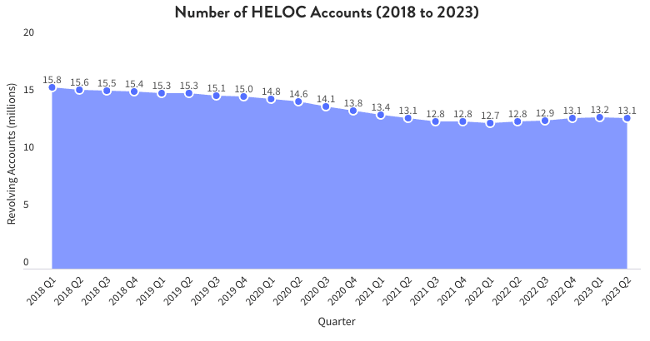
2. As of June 2024, the average interest rate for a HELOC was roughly 9.17%, however this might vary depending on credit score and lender rules. A graph showing a line graph

   Description automatically generated  
     
   A screenshot of a screen

   Description automatically generated
3. The typical HELOC credit line ranges from $75,000 to $175,000.

**Conclusion:**

Home equity lines of credit (HELOCs) provide homeowners with a flexible and potentially cost-effective alternative to obtain finances. However, borrowers must be aware of the hazards and carefully examine their capacity to repay the loan. Understanding the conditions and maintaining up to date on interest rates can help borrowers maximise the benefits of their HELOCs while minimising financial risks.